FHS Thinking Frame-Explain why

Thinking skills
Name …………………………………… Science class ………………….. Date ………………..

Current level……………….. Working towards level……………………….

Key Question: Explain why ………………………………………………………………………………….....
…………………………………………………………………………………………………………………………………….
Explore and Discover

Brainwaves
Key idea I’m going to use: ENERGY / FORCES / PARTICLES / LIFE & SURVIVAL
See / Visualise

FHS Thinking Frame-Explain why

Thinking skills

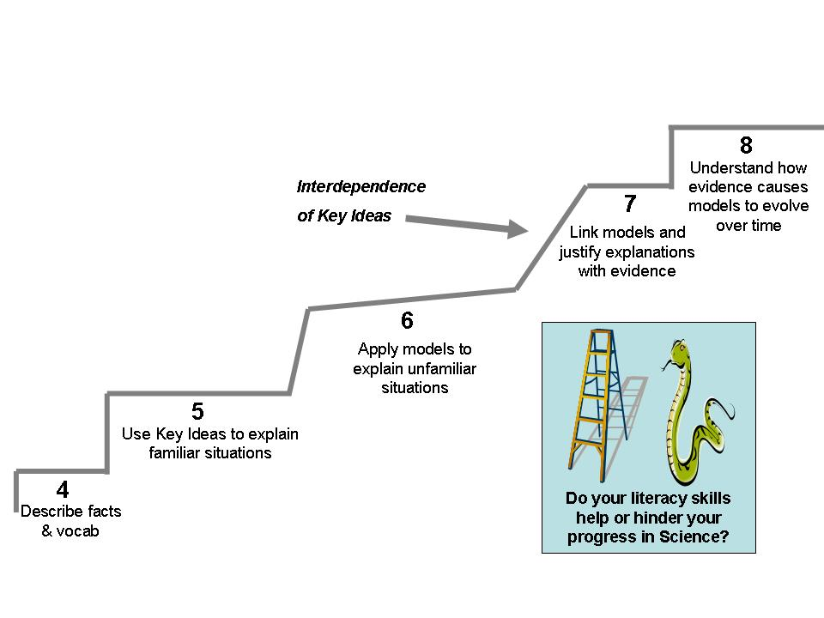Think / Sequence
Why
What happens
I think that this work is level …………
WWW …………………………………........................................
…………………………………………….…………………………..
EBI………………………………………………………………………….

Paragraph
Write your answer to the problem as fully as you can. (HINT - Use cause & effect connectives e.g. consequently, because, whenever, depending upon, eventually, since/until etc)
……………………………………………………………………………………………………………………………………………………………………………………………………………………………………………………………………………………………………………………………………………………………………………………………………………………………………………………………………………………………………………………………………………………………………………………………………………………………………………………………………………………………………………………………………………………………………………………………………………………………………………………………………………………………………………………………………………………………………………………………………………………………………………………………………………………………………………………………………………………………………………………………………………………………………………………………………………………………………………………………………………………………………………………………………………………………………………………………………………………………

